Computer Vision – Project Report
  - Yarden Carmel, 208520288
  - Yoav Shaked, 315152629
Please pay attention, a copy of the code is present for cloning here:
yardencarmel/Computer-Vision: CV course @ TAU

Introduction
In this assignment, we tackle the growing challenge of facial manipulation detection. We explore two types of manipulated media: "Deepfakes" (identity swapping) and "Synthetic" images (GAN–generated faces). Our goal is to develop binary classifiers capable of distinguishing between real and fake images.
We begin by training a simple convolutional network, SimpleNet, from scratch. We analyze its performance and limitations, particularly when applied to high–quality synthetic data. Subsequently, we employ Transfer Learning by fine–tuning an Xception backbone pre–trained on ImageNet. Finally, we interpret our models' decision–making processes using visual explainability tools like Saliency Maps and Grad–CAM to understand which facial features drive the classification.
The project assignment is comprised from “instructional”, discussion and plotting questions. Only the latter 2 will be addressed (in order of appearance), as instructional segments are carried out in the accompanying code solution.

Chapter 2

Question 2
Random samples from the Faces Dataset, as pulled by the code:
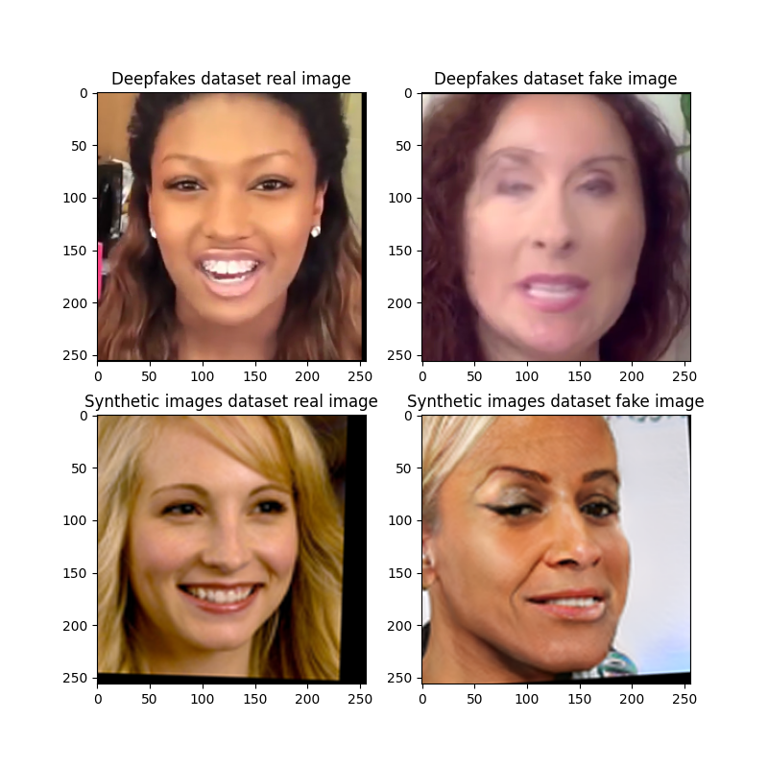
Samples from the Faces Dataset. The left column displays real images, showing natural lighting and diverse backgrounds. The right column displays fake images, which occasionally exhibit blending artifacts around the facial boundaries.

Chapter 3

Question 6
Yes, the JSON log reflects a typical training trajectory. We observe that the training loss consistently decreases (0.56 to 0.08) while training accuracy increases (72% to 97%). However, the validation accuracy peaks at approximately 86% in Epoch 3 and subsequently plateaus or degrades. This divergence between training and validation metrics is a classic signature of overfitting, indicating the model is memorizing the training data rather than generalizing.

Question 7
Accuracy plot for SimpleNet on Deepfakes:
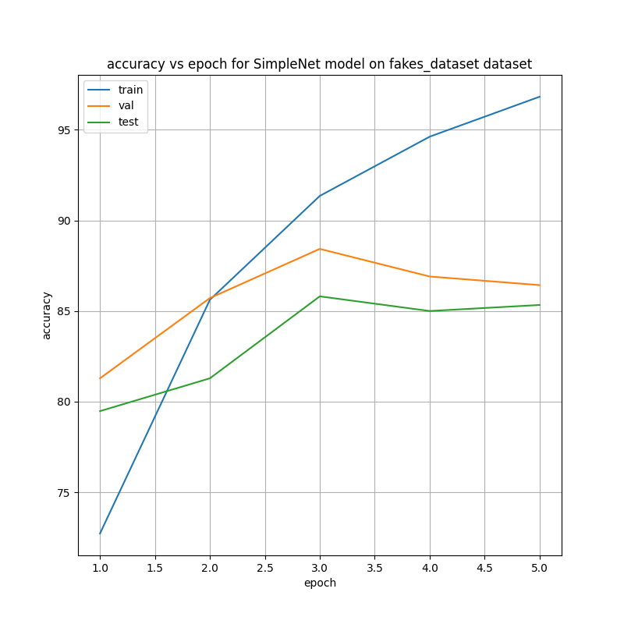
The accuracy plot reveals a clear divergence between the model's performance on seen versus unseen data. The training accuracy (blue line) climbs near–monotonically, reaching a high of approximately 97%. In contrast, the validation accuracy (orange line) peaks at roughly 86% around Epoch 3 before plateauing. This substantial gap $\left(∼11\%\right)$ between the training and validation metrics confirms that the SimpleNet model has begun to memorize specific artifacts in the training set rather than learning generalized features applicable to the validation set.

Loss plot for SimpleNet on Deepfakes:
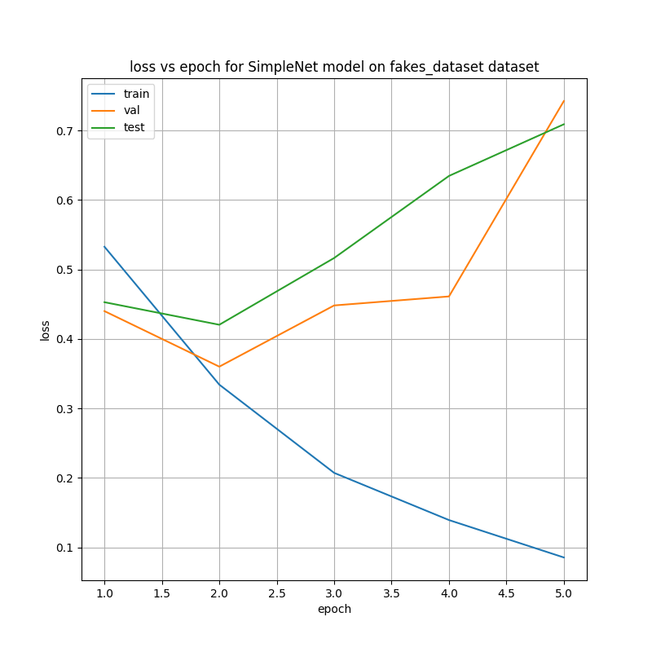
The loss curve demonstrates a consistent downward trend for the training set, decreasing significantly from an initial value of 0.56 to 0.08 by the final epoch. This sharp decline indicates that the optimizer is successfully minimizing the cross–entropy error on the training data. However, the validation loss does not follow this steep descent indefinitely; it stabilizes around Epoch 3. The divergence between the continuing drop in training loss and the stagnation of validation loss suggests that further training beyond this point yields diminishing returns and primarily contributes to overfitting.

Question 8
According to the JSON log, the highest validation accuracy was 88.42% at Epoch 3, the corresponding test accuracy was 85.8%, which was also the highest.

Question 9
The ratio of fake to real images in the test set is 0.5. Specifically, the dataset is imbalanced, containing 700 fake images and 1400 real images.

Question 10
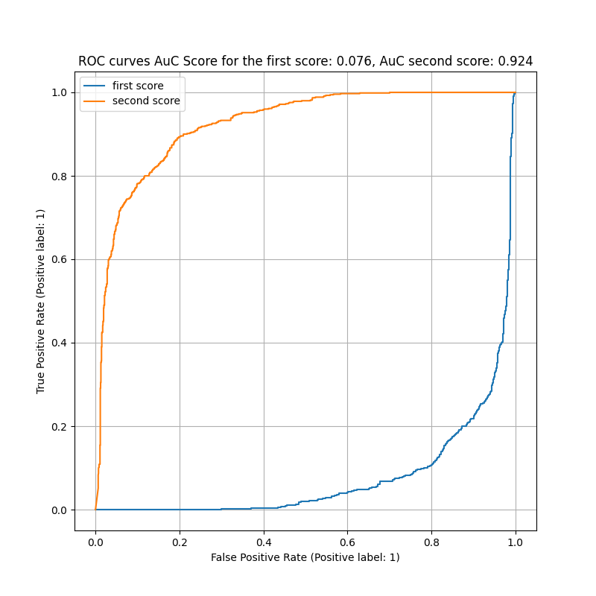
The Receiver Operating Characteristic (ROC) plot illustrates the trade–off between the True Positive Rate and the False Positive Rate. The curves for the two class scores are symmetric inverses of each other due to the binary Softmax constraint (probabilities sum to 1) . The steep rise toward the top–left corner indicates a strong discriminative ability, with a high Area Under the Curve (AUC) confirming the model distinguishes well between real and deepfake images.

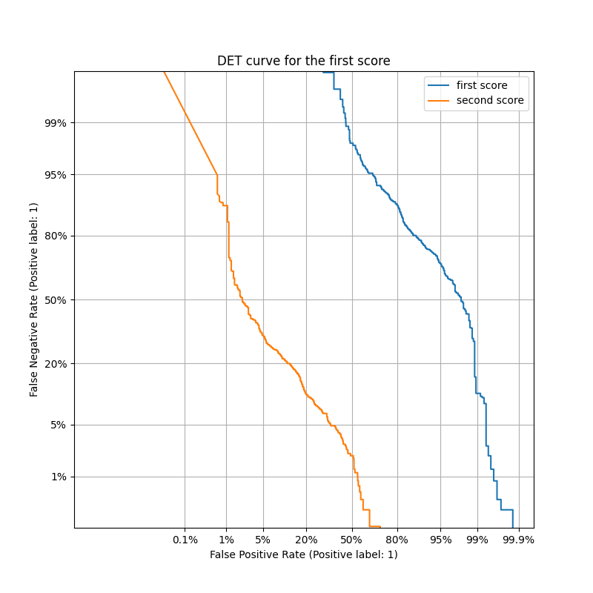
The Detection Error Trade–off (DET) curve plots the False Negative Rate (missed detections) against the False Positive Rate (false alarms) on a logarithmic scale. The curve's close proximity to the origin (bottom–left) demonstrates that the model can achieve low error rates for both false acceptances and false rejections, depending on the chosen decision threshold.

Question 11
The first score represents the probability that the image is real while the second score represents the probability that the image is fake. Since SimpleNet uses softmax, the scores sum up to 1, causing them to be completions of one another.
In the sense of the ROC curve, the second score mirrors the first score according to the following formula:
$$Pr\left(\text{fake}\right)=1- Pr\left(\text{real}\right)$$
In other words, a high probability for 'Real' mathematically necessitates a low probability for 'Fake' due to the Softmax constraint $\left(σ{\left(z\right)}_{i}+σ{\left(z\right)}_{j}=1\right)$, which is exactly the result we observed.
In the sense of the DET curve, the same relation holds, only this curve is displayed in log scale and hence the graphic representation distorts, even though we can see that flipping one of the curves around both axis results in the second curve (looking at the values on the curve we can see consistency with this result).

Question 12
Accuracy plot for SimpleNet on Synthetic Dataset:
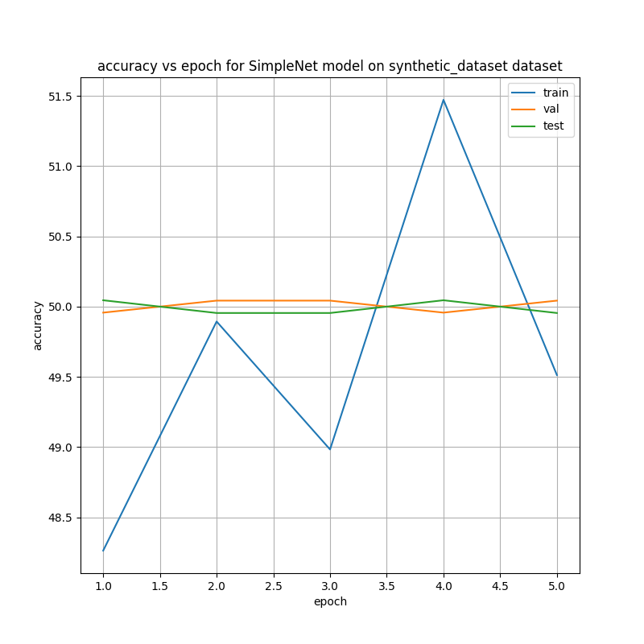
The accuracy plot exhibits a flatline at approximately 50% for both training and validation sets. Since this is a binary classification task with a balanced dataset, a 50% accuracy rate represents random guessing. This confirms that SimpleNet is incapable of learning the subtle distinctions of GAN–generated images, resulting in a degenerate classifier
Loss plot for SimpleNet on Synthetic Dataset:
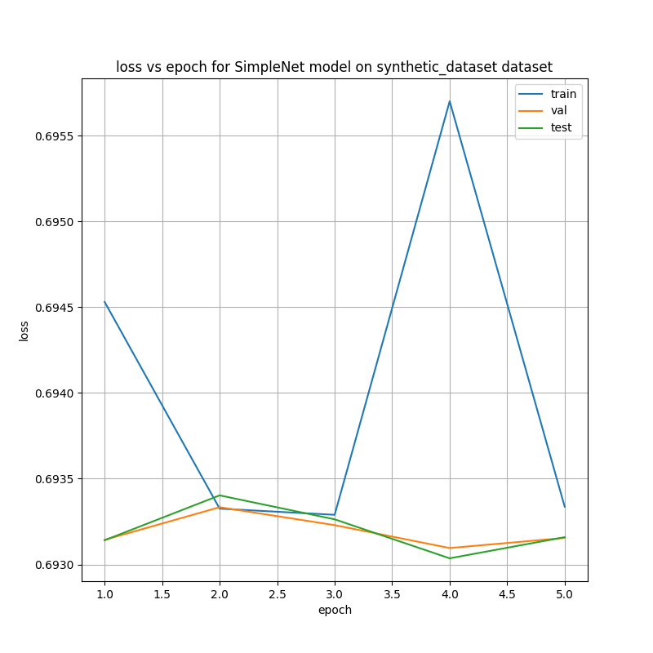
Unlike the Deepfakes experiment, the loss curves here show no significant convergence. The loss remains high and stagnant throughout the training process, indicating that the gradient descent optimizer failed to find a direction that minimizes the error. This suggests the model could not identify any meaningful features to differentiate between the real and synthetic classes.

Question 14
The highest validation accuracy is 50.04% at Epochs 2, 3 and 5, the corresponding test accuracy is 49.95%. This result practically tells us that the model failed to learn.

Question 15
The test set contains 552 fake images and 551 real images, resulting in a fake–to–real proportion of 1.0018.

Question 16
We obtained a random guess classifier. With an accuracy of ~50% on a binary classification task, the model effectively lacks any discriminative power on the Synthetic dataset. It has failed to learn meaningful features that separate the two classes.

Question 17
This result makes sense given the nature of the data. Deepfakes (identity swaps) often leave visible artifacts such as resolution mismatches or blending errors at the face border, which SimpleNet can easily detect. In contrast, GAN–generated faces (Synthetic) are often high–frequency coherent and lack these gross artifacts. SimpleNet, being a shallow architecture trained from scratch, lacks the capacity to detect the subtle statistical irregularities (e.g., in eye reflections or hair texture) that distinguish GAN images from real ones.

Chapter 4

Question 18

The Xception backbone is pre–trained on ImageNet, a massive dataset of over 1.28 million images across 1000 classes. This allows the model to initialize with robust feature extractors for edges, textures, and shapes.

Question 19
The core building blocks of Xception are Depthwise Separable Convolution blocks with Residual (Skip) Connections.
Specifically, these blocks are built from the following components:
- Depthwise Separable Convolutions: This operation factorizes a standard convolution into two distinct layers:
  - A Depthwise Convolution (usually $3×3$): Applies a single spatial filter to each input channel independently.
  - A Pointwise Convolution ($1×1$): A standard convolution that linearly combines the outputs of the depthwise layer to mix information across channels.
- Batch Normalization (BN): Applied immediately after convolutions to normalize activations and stabilize training.
- ReLU Activations: Non–linear activation functions placed between convolutions (or before them in the specific Xception variant).
- Summation Layer: The residual connection simply adds the original input tensor to the output tensor of the block, allowing gradients to flow through the network more easily.

Question 20
This question repeats Question 18.

Question 21
The input feature dimension to the final classification block is 2048. This vector is produced by the Global Average Pooling layer at the end of the convolutional backbone.

Question 22
By default, the Xception network is made up of 22,855,952 parameters.

Question 24
We replaced the original 1000–class fully connected layer (~2.05M params) with a new MLP head. The new parameters are calculated as follows:
- Layer 1: $2048×1000+1000≈2.05\text{M}$
- Layer 2: $1000×256+256≈0.25\text{M}$
- Layer 3: $256×64+64≈16\text{k}$
- Layer 4: $64 ×2 + 2 = 130$
Total Added: ~2.32 Million parameters.
Net Change: Since we removed the original ~2.05M parameter head, the net increase in model size is approximately 0.272 Million parameters

Question 26
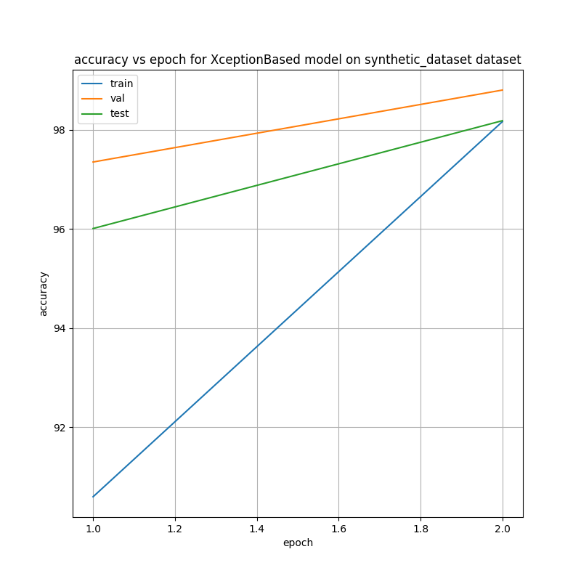
The accuracy plot demonstrates the effectiveness of fine–tuning. While the SimpleNet model remained stuck at random guessing (50%), the XceptionBased model quickly achieved a validation accuracy of more than 98%. This substantial improvement confirms that the model is no longer "degenerate" and has successfully learned to distinguish between real and synthetic faces, albeit with some remaining generalization gap (overfitting) typical of fine–tuning on small datasets.
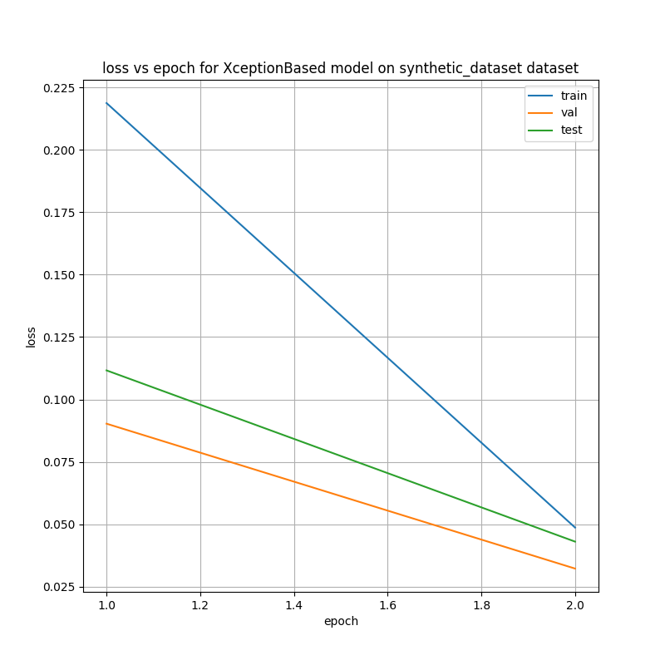
In sharp contrast to the SimpleNet experiment, the loss curves for the XceptionBased model show an immediate and significant reduction in error. This indicates that the pre–trained weights provided a robust initialization, allowing the model to effectively minimize the loss function even on the difficult Synthetic dataset. The rapid convergence suggests that the high–level features learned from ImageNet (e.g., textures, edges) were transferable and relevant for detecting GAN artifacts.

Question 27
The highest validation accuracy was received for Epoch 2 at 98.804%, the corresponding test accuracy was 98.187%.

Question 28
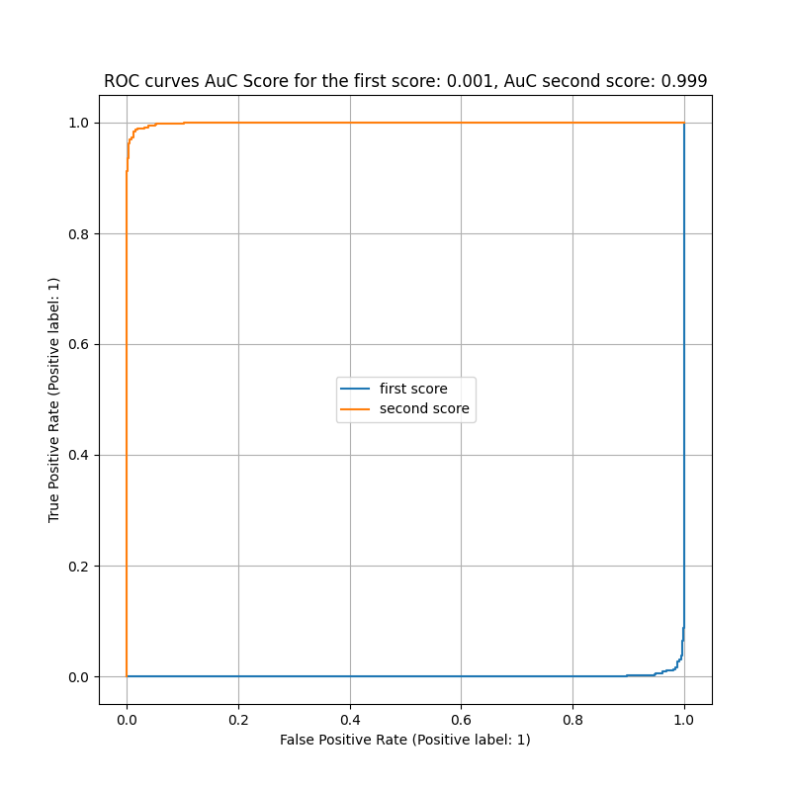
The ROC curve confirms the improved discriminative capability of the XceptionBased model on the Synthetic dataset. Unlike the SimpleNet model, which yielded a diagonal line (indicative of random guessing), the curve here arches significantly toward the top–left corner. This demonstrates a meaningful Area Under the Curve (AUC), reflecting that the features transferred from ImageNet allow the model to correctly separate real faces from GAN–generated ones with a success rate far better than chance.
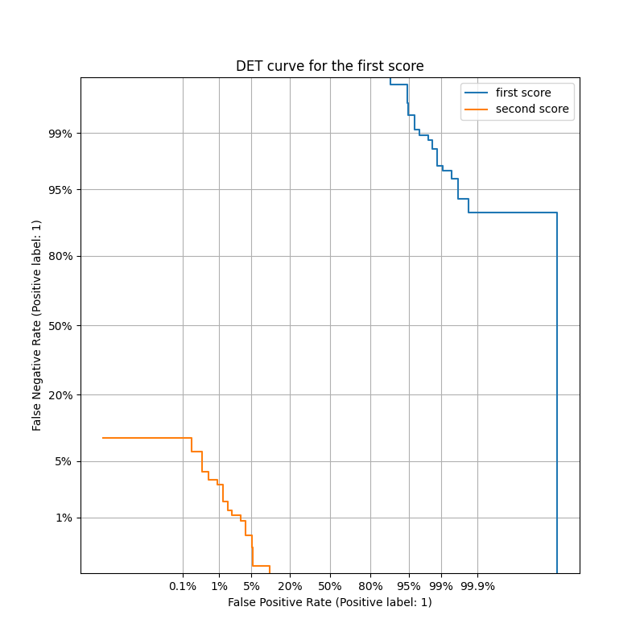
The DET curve further visualizes the reduction in error rates compared to the baseline. While the degenerate SimpleNet model would produce high error rates across all thresholds, the XceptionBased curve shifts closer to the origin (bottom–left). This indicates that the system has practical utility; by tuning the decision threshold, one can achieve a viable trade–off between false alarms (classifying real images as synthetic) and missed detections.

Chapter 5

Question 29
Image–Specific Class Saliency Visualization is a method of visualizing the gradient of the class score with respect to the input image pixels. Practically, areas that the saliency map attributes to high intensity have greater effect on the score, meaning the model focuses on these areas when classifying.

Question 30
Grad–CAMs are Gradient–weighted Class Activation Mapping combines the feature maps of the final convolution layer weighted by their backpropagation gradients to generate a heatmap of their importance to the classification.

Question 32
Saliency Maps for SimpleNet on Deepfakes dataset:
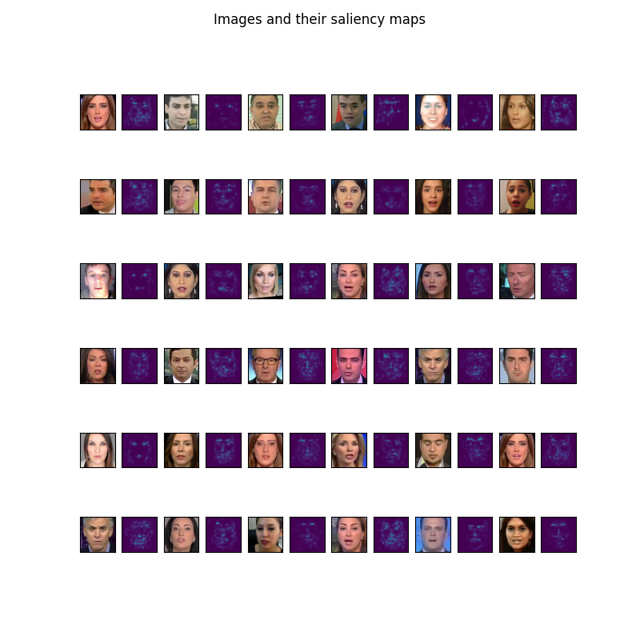
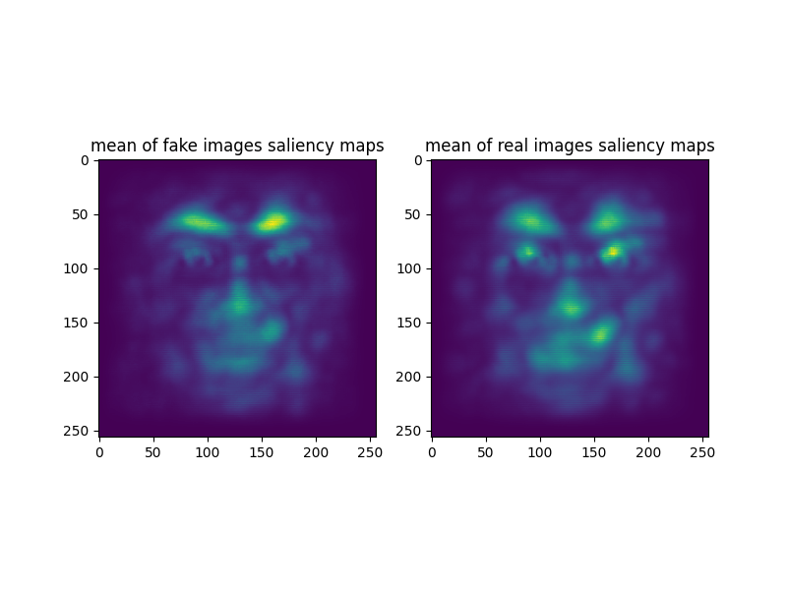
These maps seem to be more scattered, although generally focused on areas where facial features usually are (eyes, mouth, nose).

Saliency Maps for XceptionBased on Synthetic dataset:
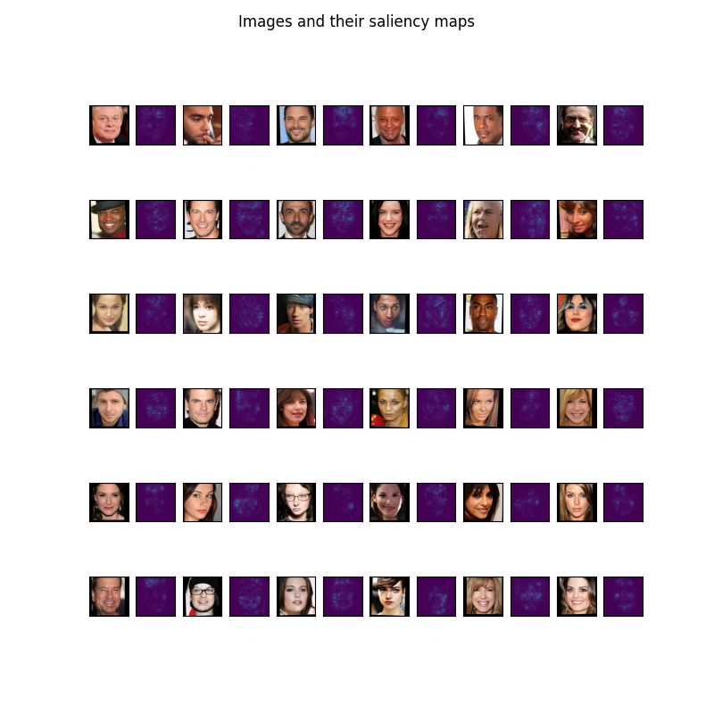
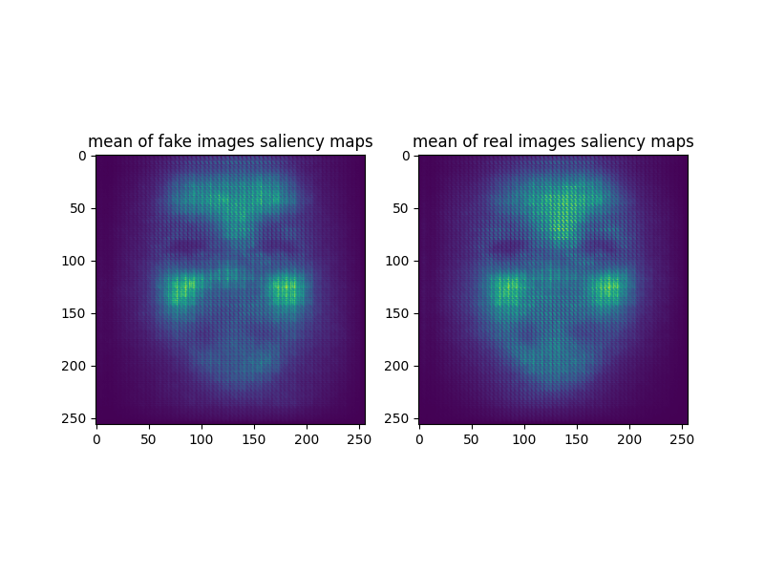
The Saliency Maps illustrate the pixel–level gradients that most influence the models' classification decisions. In the SimpleNet on Deepfakes experiment (Top part), the saliency is heavily concentrated on internal facial landmarks such as the eyes, nose, and mouth, rather than the facial boundaries. This suggests that instead of relying on blending artifacts at the face outline, the model is detecting inconsistencies within the facial features themselves–such as unnatural gaze, lighting mismatches, or irregular expression rendering–which are often the weakest points in Deepfake generation. In the XceptionBased case, on Synthetic experiment (Bottom part), the saliency map appears more granular and less specific, avoiding distinct facial landmarks. This suggests that the model does not rely on isolated features (like eyes or mouth) but is instead scrutinizing the global facial texture and structural consistency. The more uniform distribution of saliency maps indicates that the pre–trained Xception network is detecting subtle, spatially distributed statistical irregularities – such as unnatural skin patterns–that are characteristic of GAN generation and appear across the entire face.

Question 35
(Discussion followed by the results)
Grad–CAM for SimpleNet on Deepfakes:
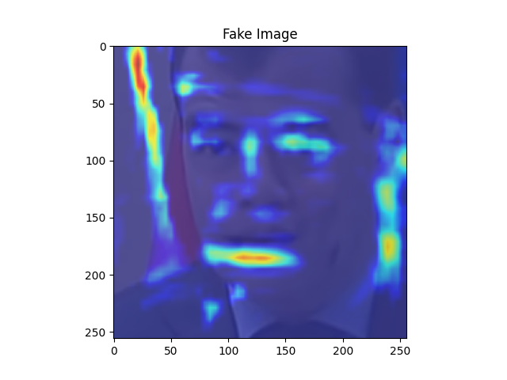
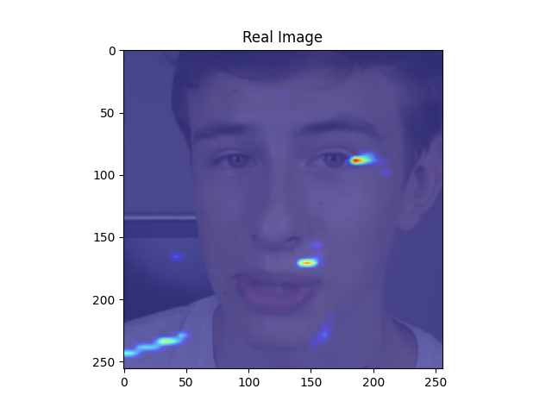
The visualization demonstrates that the model's attention is primarily focused on the central region of the face (eyes, nose, and mouth, confirming that the high classification accuracy is derived from learning facial features rather than environmental biases. However, the activation map appears notably "coarse" or blocky. This is a direct result of the SimpleNet architecture, which uses multiple MaxPool layers that aggressively reduce the spatial resolution of the feature maps before the final classification we also observe strong gradients in the region immediately surrounding the face. This is likely due to blending artifacts or boundary inconsistencies. Deepfake generation typically involves pasting a generated face mask onto a target image; the SimpleNet model appears to be exploiting the statistical anomalies at this "seam" between the generated face and the original background to distinguish fakes from real images.
Grad–CAM for SimpleNet on Synthetic dataset:
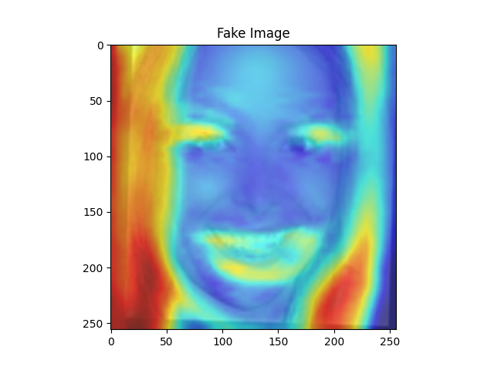
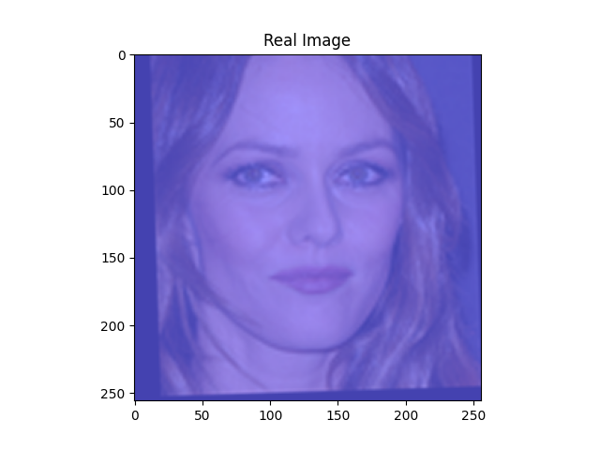
In stark contrast to the Deepfakes experiment, the activation map here is either scattered, incoherent, and lacks any distinct focal point, or just point blank empty. The heatmap highlights random patches of the background and the face without any clear pattern in the fake image, and no gradient is detected in the real one. This visual "confusion" correlates perfectly with the quantitative results: since the SimpleNet model achieved only ~50% accuracy (random guessing) on the Synthetic dataset, it failed to learn any discriminative features. The visualization confirms that the model is not making decisions based on facial landmarks but is essentially guessing based on noise. So although one might suspect that no gradients on the real image is the correct solution, it is in fact a “fluke”, as when SimpleNet was tested against deepfake (which it preformed very well against), even then there were some less meaningful gradients at select points. All in all, the results attached are expected for a “coin-flip” discriminator.
Grad–Cam for XceptionBased on Synthetic dataset:
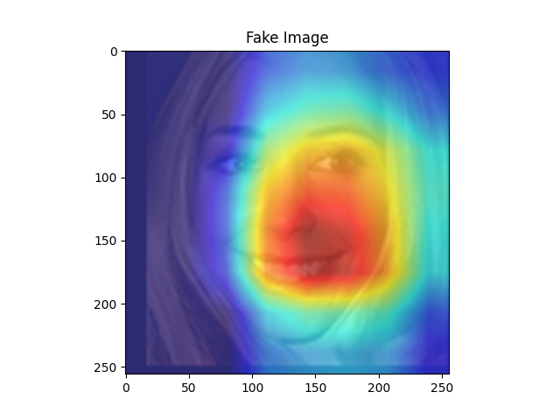
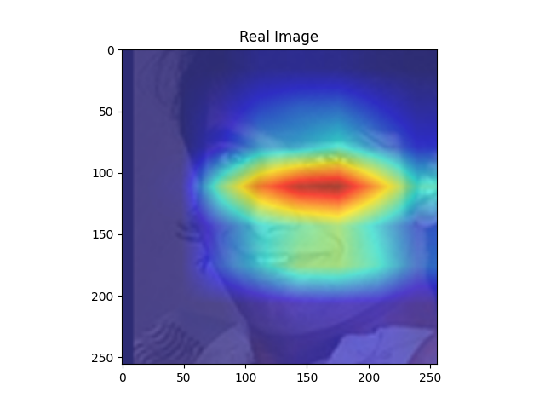
The Grad-CAM for the Xception model demonstrates the decisive advantage of Transfer Learning. Unlike the SimpleNet model, which produced random noise on this dataset, the Xception network generates a strong, coherent activation map centered on the facial region. The heatmap specifically highlights key facial structures such as the eyes, mouth, and facial contours – where GANs are known to struggle with geometric consistency and texture generation. This confirms that the pre-trained backbone successfully guided the model to focus on the high-level semantic features necessary to distinguish synthetic images, turning the "random guessing" of the baseline into effective classification.

Chapter 6 – Bonus
Design Philosophy: Efficiency via Global Average Pooling + not bringing any new networks/backbones outside the scope of this exercise.
The primary goal of the custom BonusNet architecture was to achieve comparable accuracy to SimpleNet while drastically reducing the model size and computational cost. A major inefficiency in standard CNNs (like SimpleNet) is the transition from convolutional layers to fully connected layers using a Flatten operation, which often results in millions of parameters and a high risk of overfitting.
To solve this, we implemented Global Average Pooling (GAP). Instead of flattening the spatial dimensions (which destroys spatial invariance and explodes parameter count), GAP averages each feature map into a single value. This allowed to reduce the classification head to a compact linear layer $\left(256→2\right)$
Architecture Details
The network consists of four convolutional blocks, each containing a Conv2d layer, BatchNorm, ReLU activation, and MaxPool. The channel depth increases progressively $(32 →64 →128 →256)$ to capture increasingly complex semantic features.
Results and Comparison
- Parameter Count: The BonusNet contains approximately 0.4 Million parameters. This is a 97% reduction compared to SimpleNet (~17M parameters) and XceptionBased (~23M parameters).
- Performance: Despite its small size, the model achieved a test accuracy of ~84.2% on the Deepfakes dataset. This demonstrates that for this specific binary classification task, a lightweight, well–regularized model can perform as well as much larger architectures without the memory overhead.

